**Closing date and time: 00:00 midnight on 29 February 2025 it will close upon the depletion of the Budget Application must be emailed to: bursaryapplication@fasset.org.za**

# OUTSTANDING STUDY DEBT REPAYMENT APPLICATION FORM: 2024/2025



|  |
| --- |
| **SELECTION CRITERIA**  Applicant must currently be employed within the FASSET sector/ professionals affiliated with professional bodies within the FAS Sector/ cross-sectoral employers/NGOs and COBs. Applicants must have completed a qualification relevant to the FAS Sector.  Applicant that are unemployed must have completed a qualification relevant to the FAS Sector.  Employed applicant earning R660 000 or less per annum will be eligible and unemployed applicants should be coming from a household income of R660 000 or less per annum will also be eligible.  Applicant with an outstanding loan at NSFAS or higher public learning institutions which was used to fund a completed qualification relevant to FAS Sector.  Settlement amount is limited to **R80 000 per applicant per year**.  Approval will be on first come first served basis limited to budget availability.  Please refer to Section F for compulsory documents required and must be submitted in PDF format**.**  FASSET reserves the rights to decline all applications with outstanding documents.  Communication will be sent to successful applicants. |

## **SECTION A: DEMOGRAPHIC AND PERSONAL INFORMATION**



|  |  |  |  |  |  |  |  |  |
| --- | --- | --- | --- | --- | --- | --- | --- | --- |
|  |  |  | (choose one and mark with an X) | | |  | | |
| 1. | Name/s |  | 7. | Race | White |  | Indian |  |
| African |  | Coloured |  |
| 2. | Surname |  | 8. | Gender | Male |  | Female |  |
| 3. | Student Number |  | 9. | Disability | Yes |  | No |  |
| 4. | ID number |  | 10 | Type of disability | . |  | | |
| 5. | Cell number |  | 11.  . | Alternative number | |  | | |
| 6. | Email address |  |  | Disability and Type | |  | | |

## Residential details

|  |  |  |  |  |
| --- | --- | --- | --- | --- |
| 12. | Home address |  | Current address | |
| House Number:  Street Name:  Town:  Area Code:  Municipality:  Rural/Urban: |  | House Number:  Street Name:  Town:  Area Code:  Municipality:  Rural/Urban: | |
| 13. | Province (choose one and mark with an X) |  | Province (choose one and mark with an X) | |
|  | Eastern Cape |  | Eastern Cape |  |
| Gauteng |  | Gauteng |  |
| Northern Cape |  | Northern Cape |  |
| Limpopo |  | Limpopo |  |
| KwaZulu-Natal |  | KwaZulu-Natal |  |
| Western Cape |  | Western Cape |  |
| Mpumalanga |  | Mpumalanga |  |
| Free State |  | Free State |  |
| North West |  | North West |  |

### SECTION B: EDUCATION BACKGROUND AND CURRENT STUDIES



## Grade 12 information

|  |  |  |
| --- | --- | --- |
| 14. | High school attended |  |
| 15. | Local municipality |  |
| 16. | Province |  |
| 17. | Year |  |

## Qualification

|  |  |  |
| --- | --- | --- |
| 18. | University attended |  |
| 19. | Graduation year |  |
| 20. | Degree |  |
| 21. | Major (s) |  |

**NB!! Qualification provided must be linked to the outstanding loan/ fees.**

### SECTION C: EMPLOYMENT DETAILS (applicable to employed learners only)

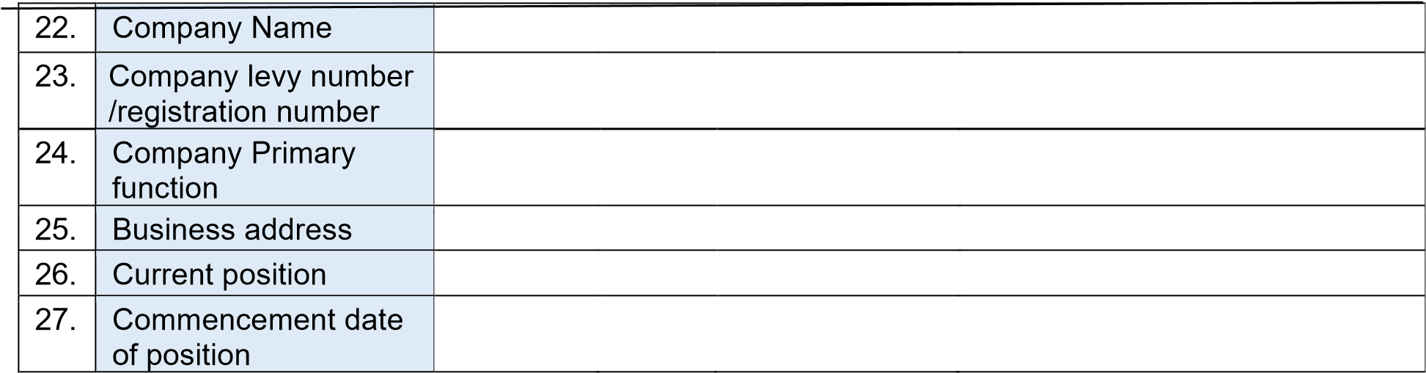

### SECTION D: POPIA DECLARATION

The individual may withdraw consent to the processing of personal information at any time, and should they wish to do so, must provide FASSET with reasonable notice to this effect. Please note that withdrawal of consent is still subject to the terms and conditions of any contract that is in place. Should the withdrawal of consent result in the interference of legal obligations, then such withdrawal will only be effective if FASSET agrees to same in writing. FASSET specifically draws to the attention that the withdrawal of consent may result in it being unable to provide the requested information and/or services and/or financial or other benefits. Further, please note that the revocation of consent is not retroactive and will not affect disclosures of personal information that have already been made. To withdraw consent, please contact the Information Officer at popia@FASSET.org.za.

Where personal information has changed in any respect, the individual is encouraged to notify FASSET so that our records may be updated. FASSET will largely rely on the individual to ensure that personal information is correct and accurate.

The individual has the right to access their personal information that FASSET may have in its possession and is entitled to request the identity of which third parties have received and/or processed personal information for the purpose. Please note however, that any request in this regard may be declined if:

* the information comes under legal privilege during litigation,
* the disclosure of personal information in the form that it is processed may result in the disclosure of confidential or proprietary information,
* giving access may cause a third party to refuse to provide similar information to FASSET,
* the information was collected in furtherance of an investigation or legal dispute, instituted or being contemplated,
* the information as it is disclosed may result in the disclosure of another person’s information,
* the information contains an opinion about another person and that person has not consented, and/or
* the disclosure is prohibited by law.

## **SECTION E: APPLICTION DECLARATION**



I, ____________________________________________, the applicant, do hereby certify that the above information is true and correct to the best of my knowledge.

Signature: _____________________________ Date: ___________________

2

### SECTION F: MANDATORY APPLICATION DOCUMENTS

_________________________________________________________________________

The following mandatory documents should accompany the application form:

|  |  |
| --- | --- |
| **Employed Applicant Requirement**    Fully completed and signed Application Form  Certified ID copy of the applicant, not older than 6 months.  An official academic transcript showing completion / official signed letter from the university showing completion / certificate showing completion of the qualification must accompany each application.  A recent copy of the applicant NSFAS fee statement or Public Higher learning institution fee statement (not older than 30 days on the day of submitting to FASSET)  Signed confirmation of employment from employer or contract of employment that demonstrates annual package.  Payslip not older than 3 months | **Unemployed Applicant Requirement**    Fully completed and signed Application Form  Certified ID copy of the applicant, not older than 6 months.  An official academic transcript showing completion / official signed letter from the university showing completion / certificate showing completion of the qualification must accompany each application.  A recent copy of the applicant NSFAS fee statement or Public Higher learning institution fee statement (not older than 30 days on the day of submitting to FASSET)  Applicant affidavit of Unemployment declaration  Proof of household income (Father and Mother/ Guardian(s)) and their certified ID copies not older than 6 months. If parents/guardian are not working, an affidavit must be provided by the parent(s)/ guardian.  A parent must provide an affidavit confirming single parent/guardianship (applicable for single parent household).  If parent(s) deceased, please provide death certificate(s). |

