|  |  |  |
| --- | --- | --- |
|  |  |  |
|  | **Delegate Attendance**  **Manual**  **March 2014** |  |
|  | http://www.fasset.org.za/images/nav_logo.gif  . |  |
|  |  |  |

# Contents

|  |  |
| --- | --- |
| Contents  1. Contents ii  1. Logging In 1  2.1 Enter Your User Name and Password 2  2.2 Click on Login 2  3. SDF Profile for Skills 2  3.1 Select Skills 2  4. Select Organisation 3  4.1 Capture the SDL number or the name of the company to display the menu 3  4.2 Click on Search 3  4.3 The company will display in the display bar – highlight the relevan line and click on the magnifying glass 3  5. The following menu will be displayed. Select the Delegate Information 4  6. Delegates who attended an intervention will be displayed. 4  6.1 Functionality is available to search on this screen using the delegate name, delegate ID number or the intervention. 5  6.2 Functionality is available to download the report to excel. 5 | **1** |

# Logging In

System URL: <http://172.16.201.30/FASSETIndicium/Account/Login.aspx>

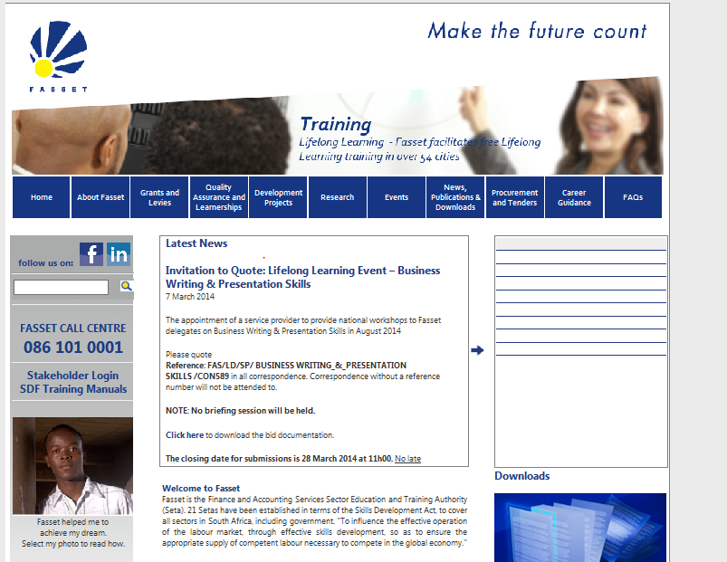

## Enter Your User Name and Password

## Click on Login

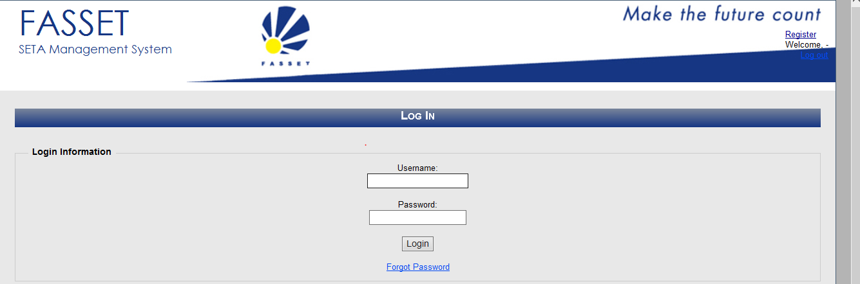

# SDF Profile for Skills

## Select Skills

# 

# Select Organisation

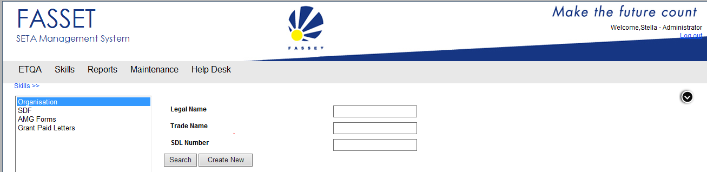

## Capture the SDL number or the name of the company to display the menu

## Click on Search

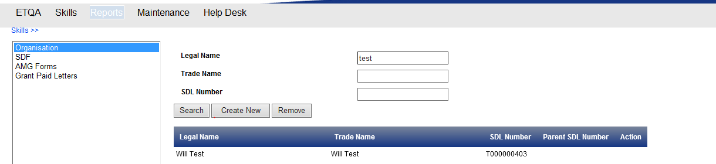

## The company will display in the display bar – highlight the relevan line and click on the magnifying glass

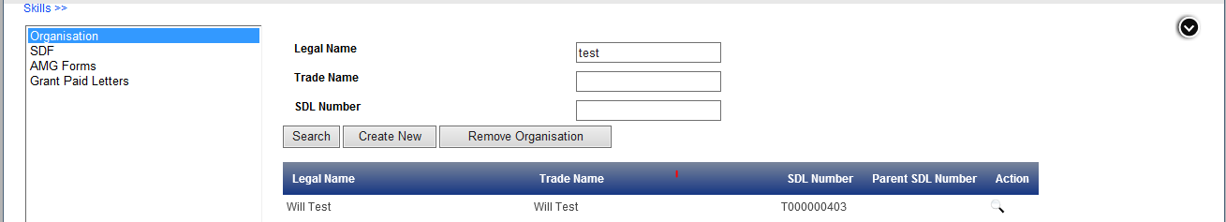

# The following menu will be displayed. Select the Delegate Information

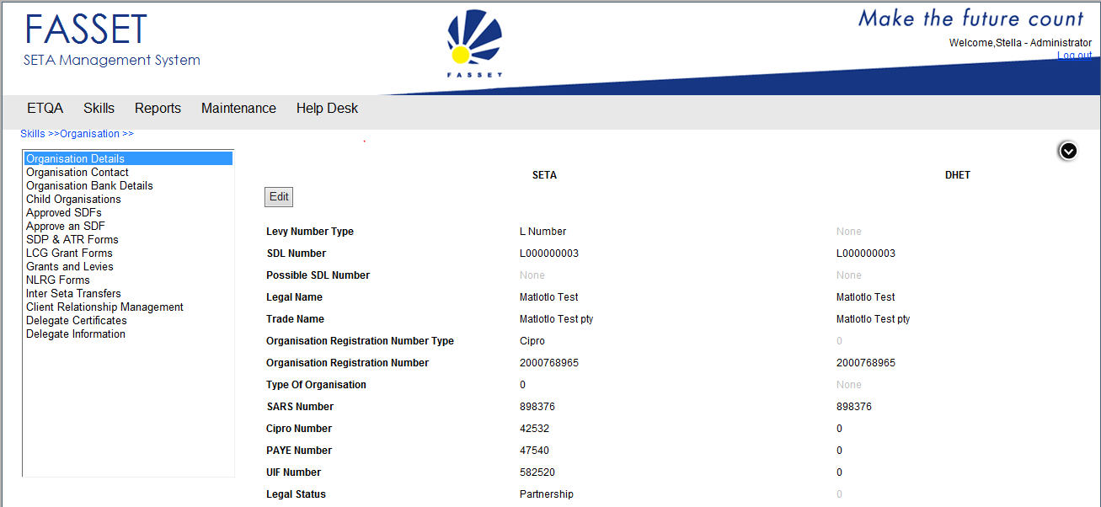

# Delegates who attended an intervention will be displayed.

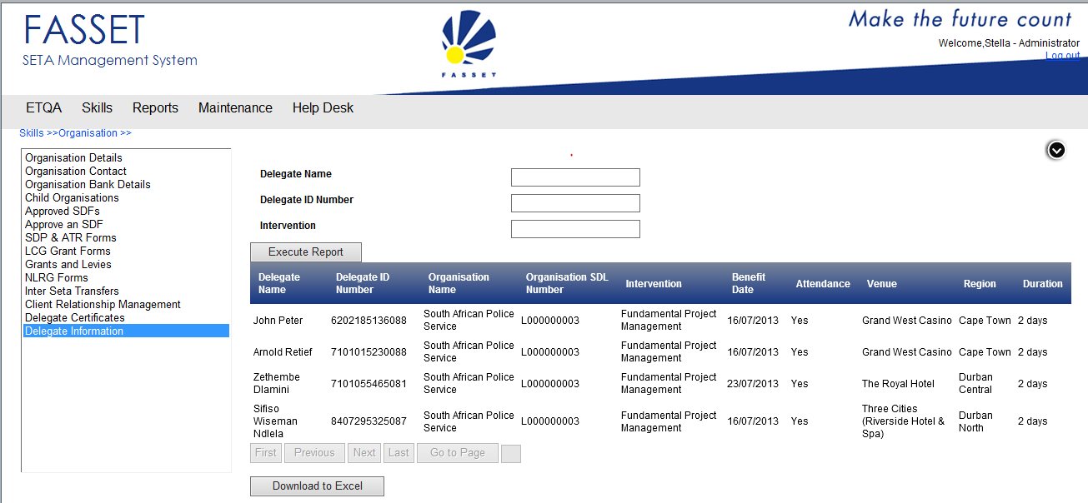

## Functionality is available to search on this screen using the delegate name, delegate ID number or the intervention.

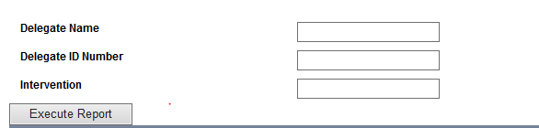

## Functionality is available to download the report to excel.

